Figure 1 Agents DDL SQL 1

Figure 2 Agents DML SQL 2

Figure 3 Customers DDL SQL 2

Figure 4 Customers DML SQL 3

Figure 5 Homes DDL SQL 3

Figure 6 Homes DML SQL 4

Figure 7 Homepage 4

Figure 8 View Data page 5

Figure 9 Insert Data page 5

Figure 10 Insert Data form filled out 6

Figure 11 Insert Success Page 6

Figure 12 Select Data after insert 7

Figure 13 Edit Data Page 7

Figure 14 Edit Data form filled out 8

Figure 15 Edit success page 8

Figure 16 Select Data after edit 9

Figure 17 Delete page 9

Figure 18 Delete record selected 10

Figure 19 Delete success page 10

Figure 20 Select Data after delete 11

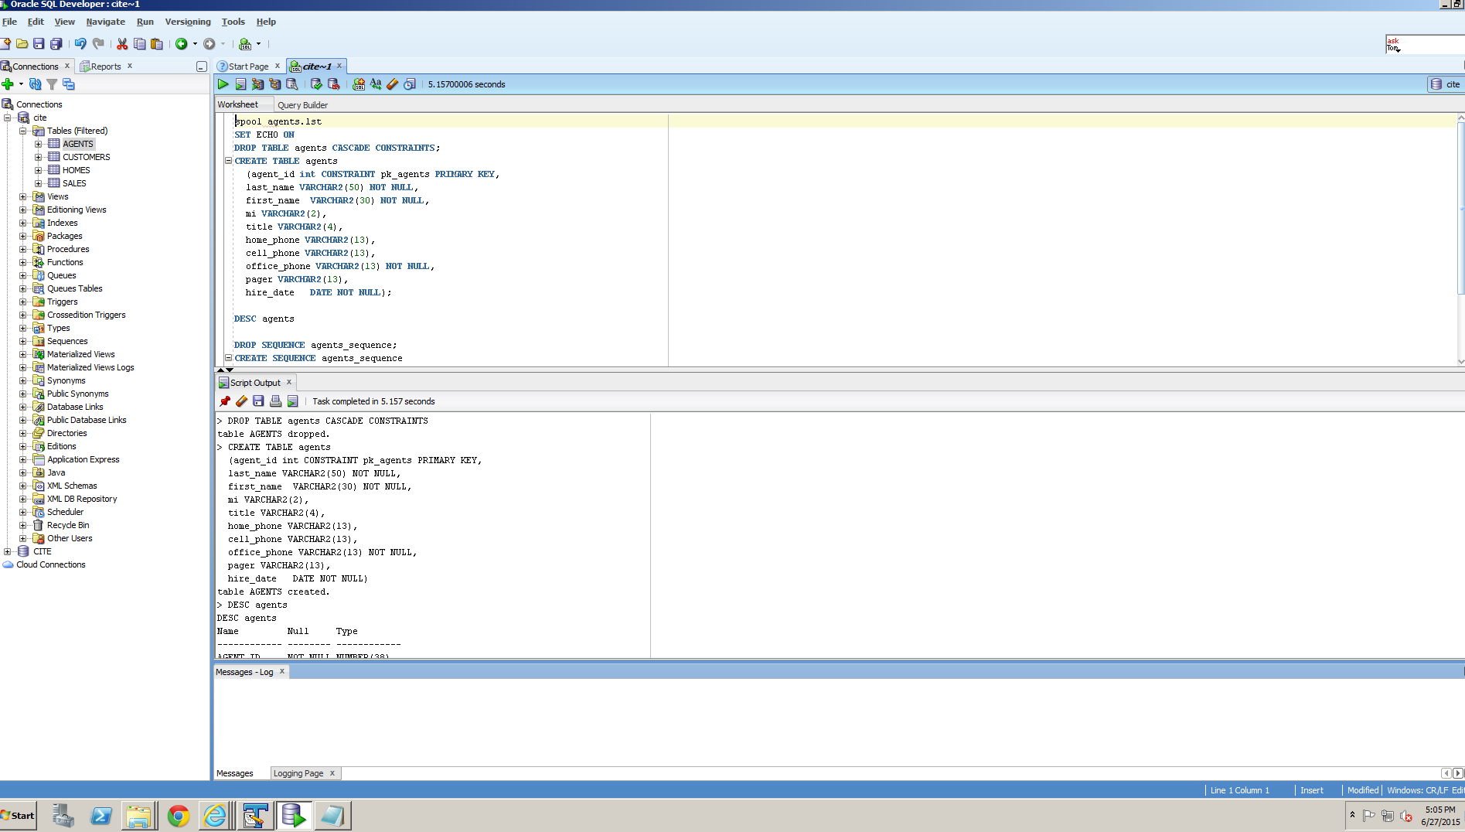

Figure 1 Agents DDL SQL

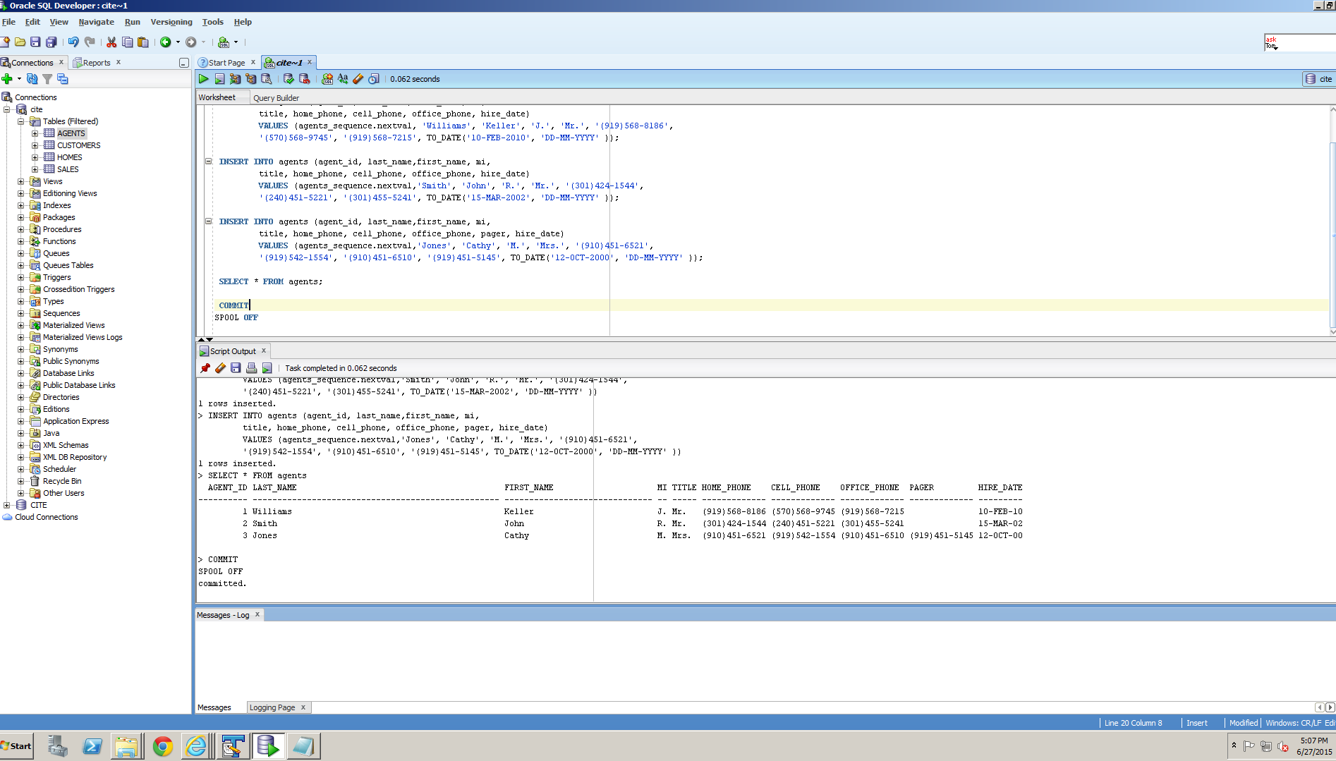

Figure 2 Agents DML SQL

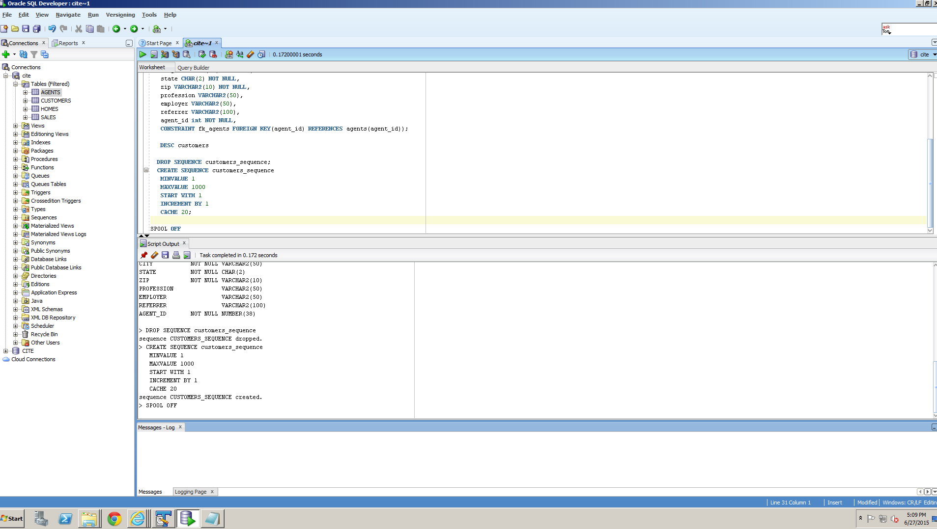

Figure 3 Customers DDL SQL

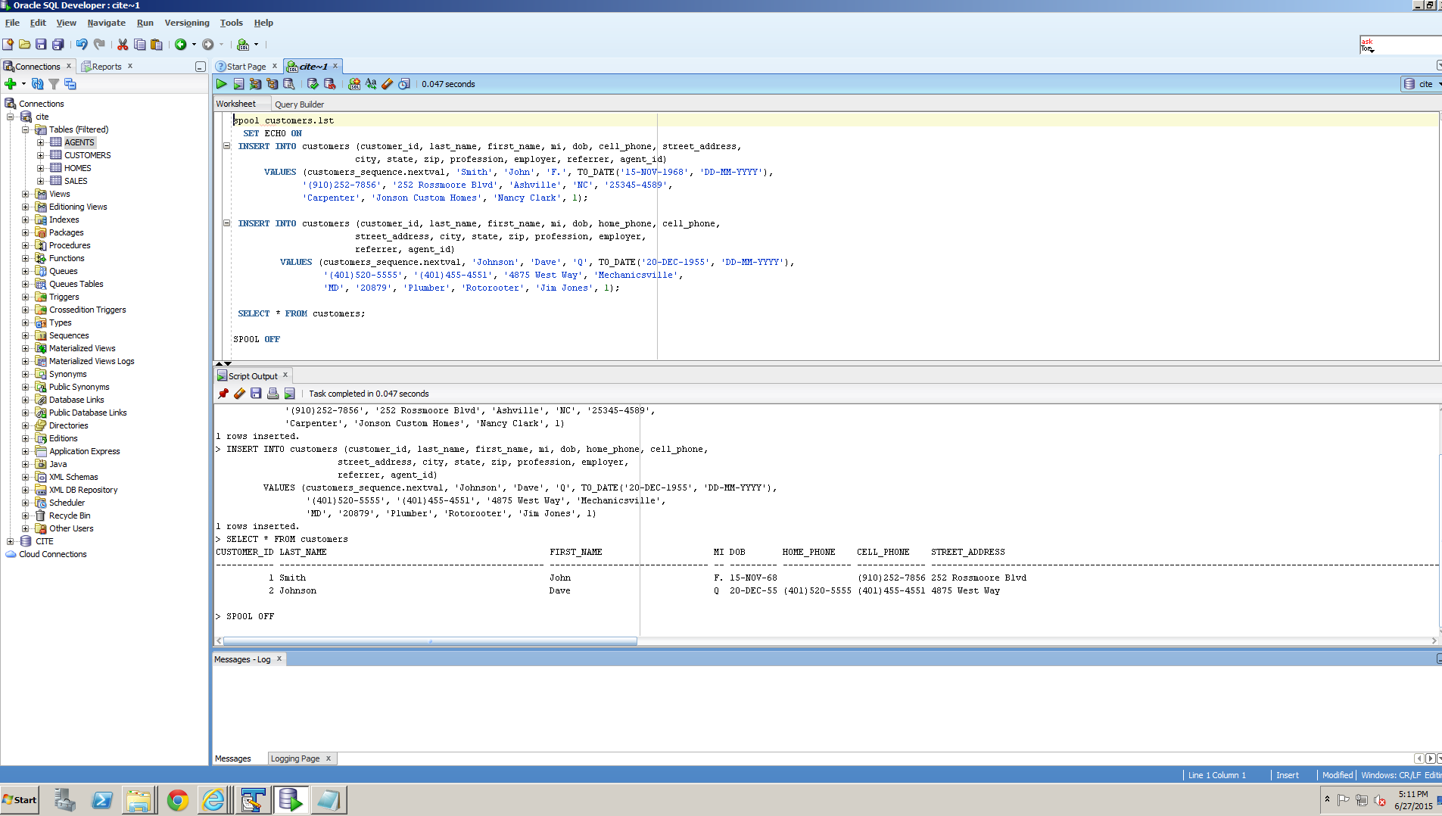

Figure 4 Customers DML SQL

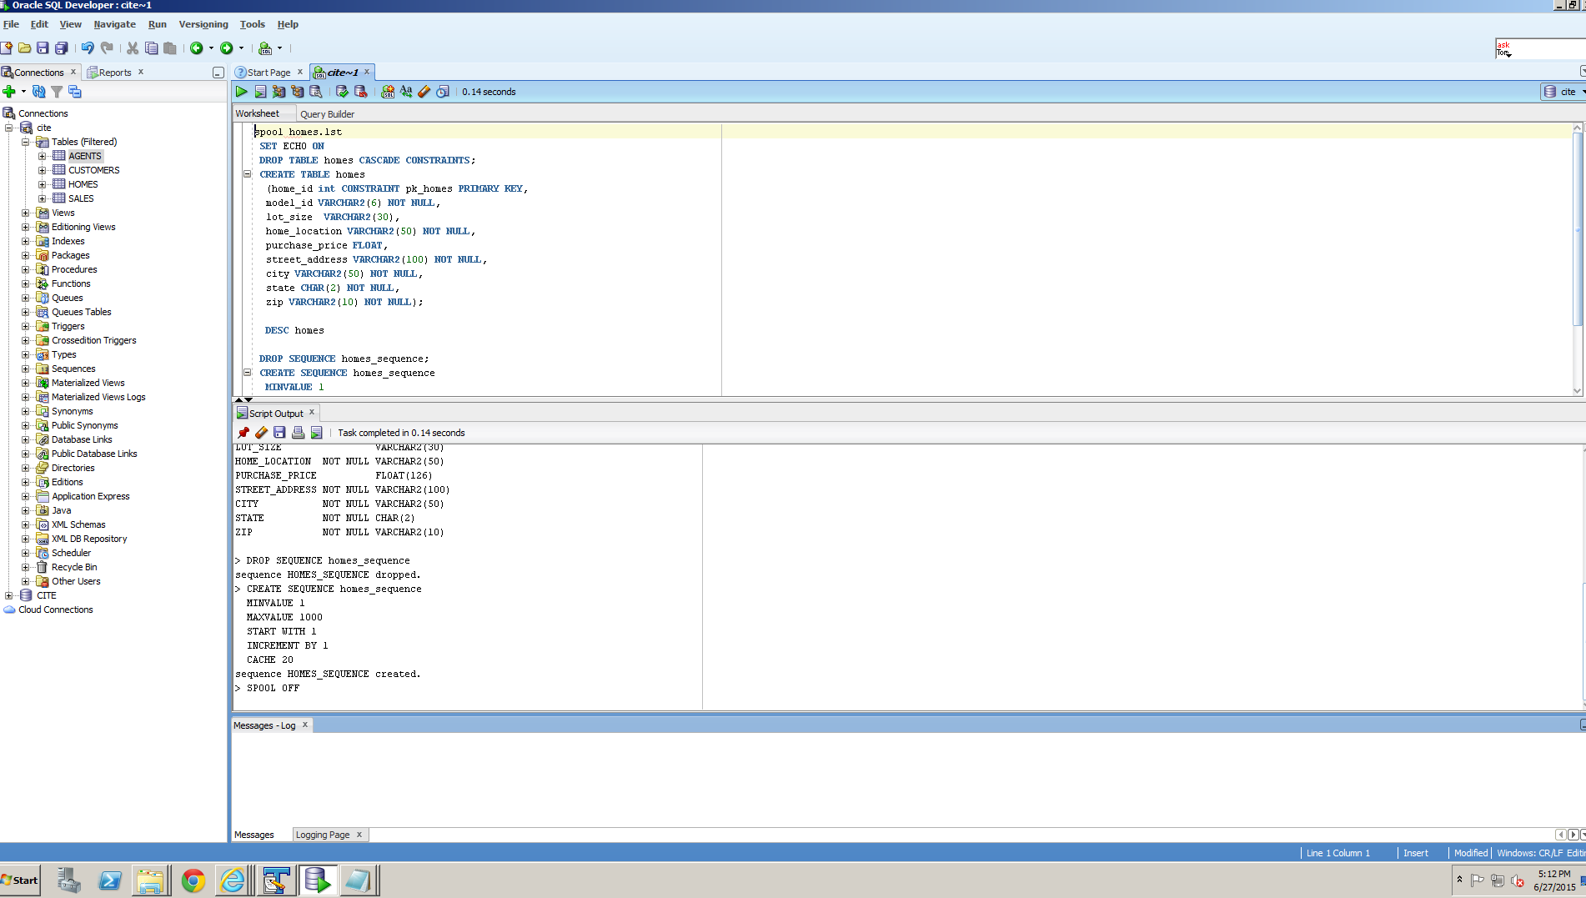

Figure 5 Homes DDL SQL

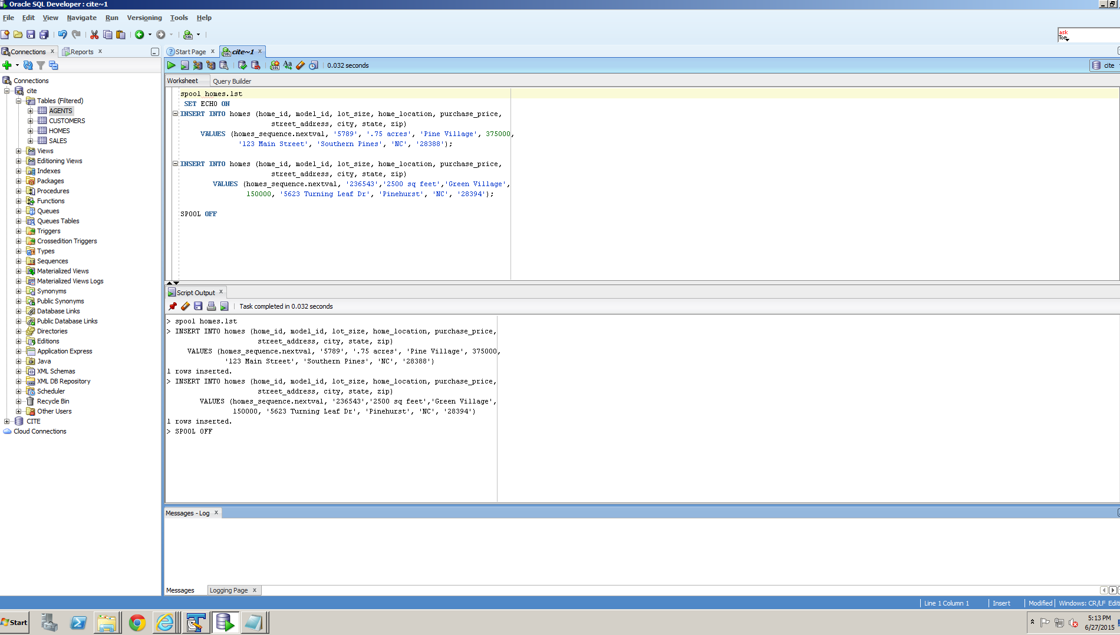

Figure 6 Homes DML SQL

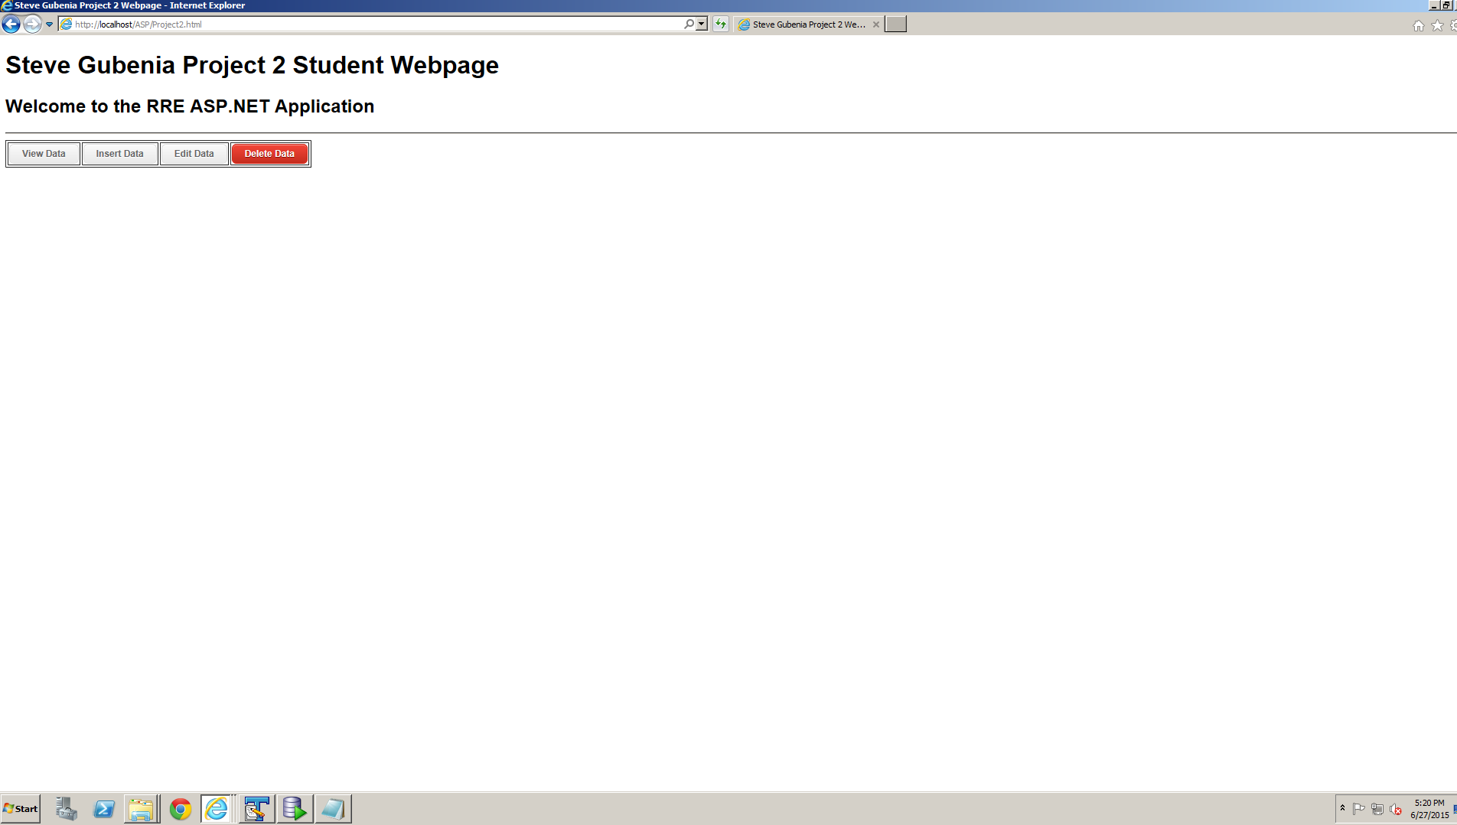

Figure 7 Homepage

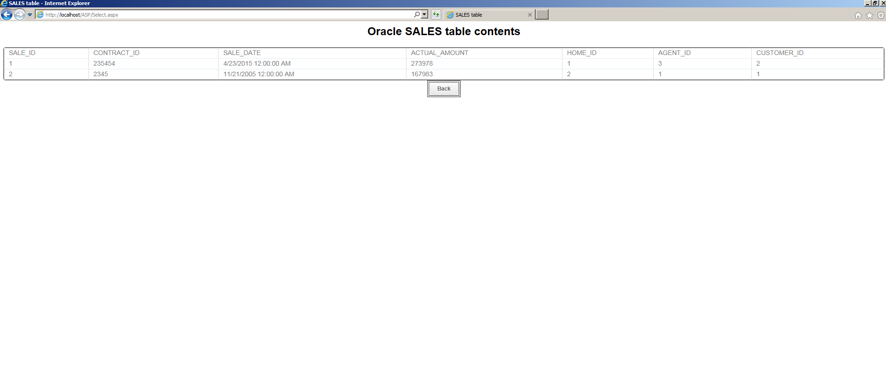

Figure 8 View Data page

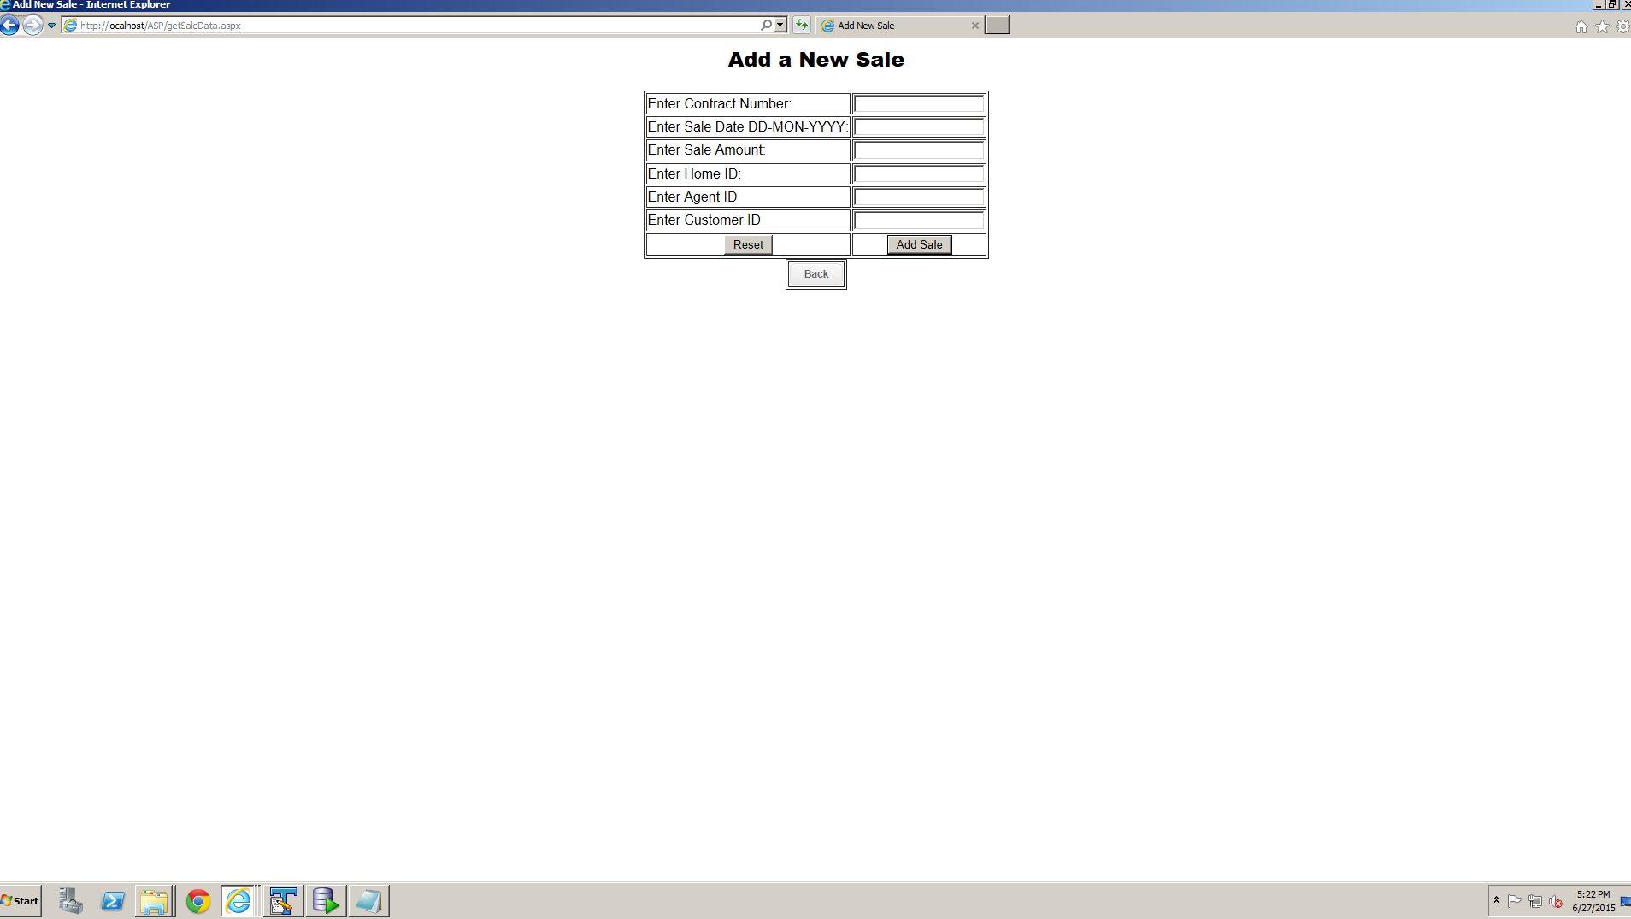

Figure 9 Insert Data page

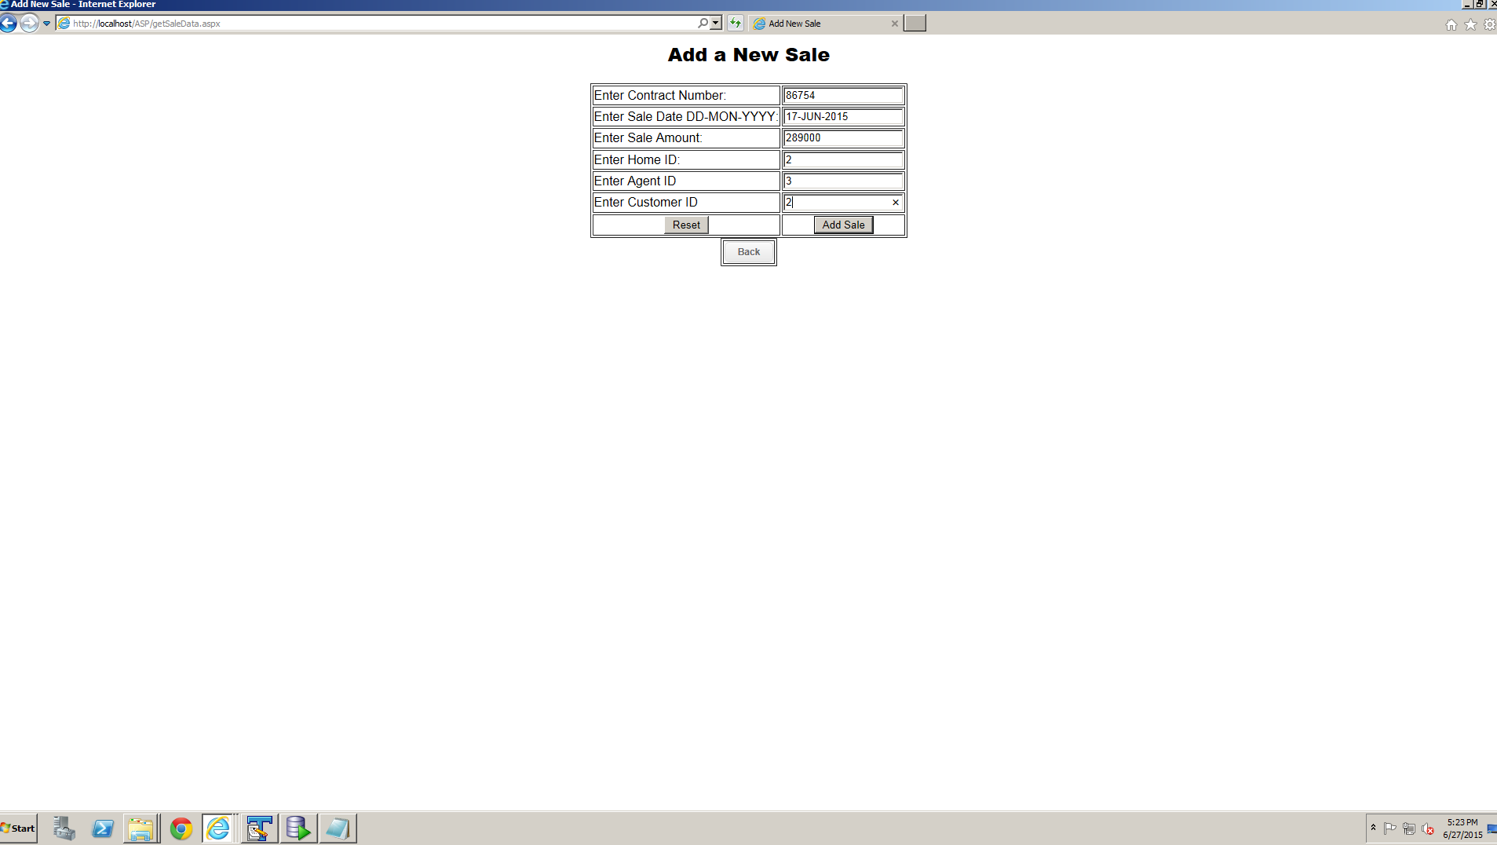

Figure 10 Insert Data form filled out

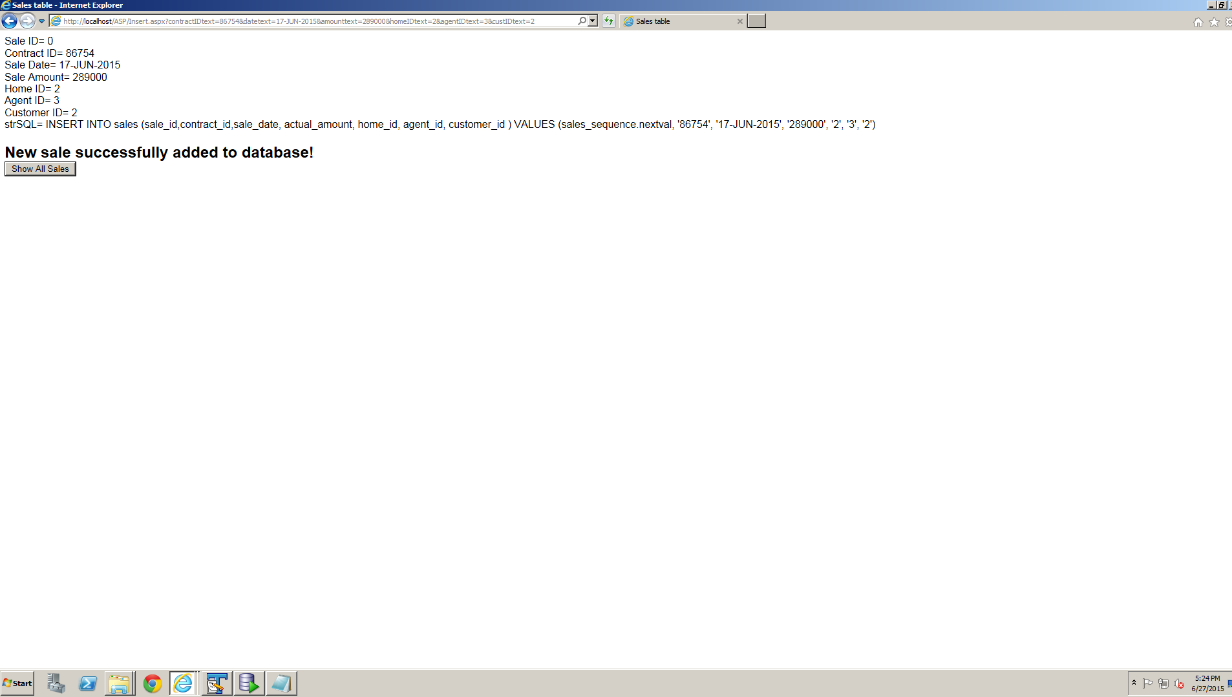

Figure 11 Insert Success Page

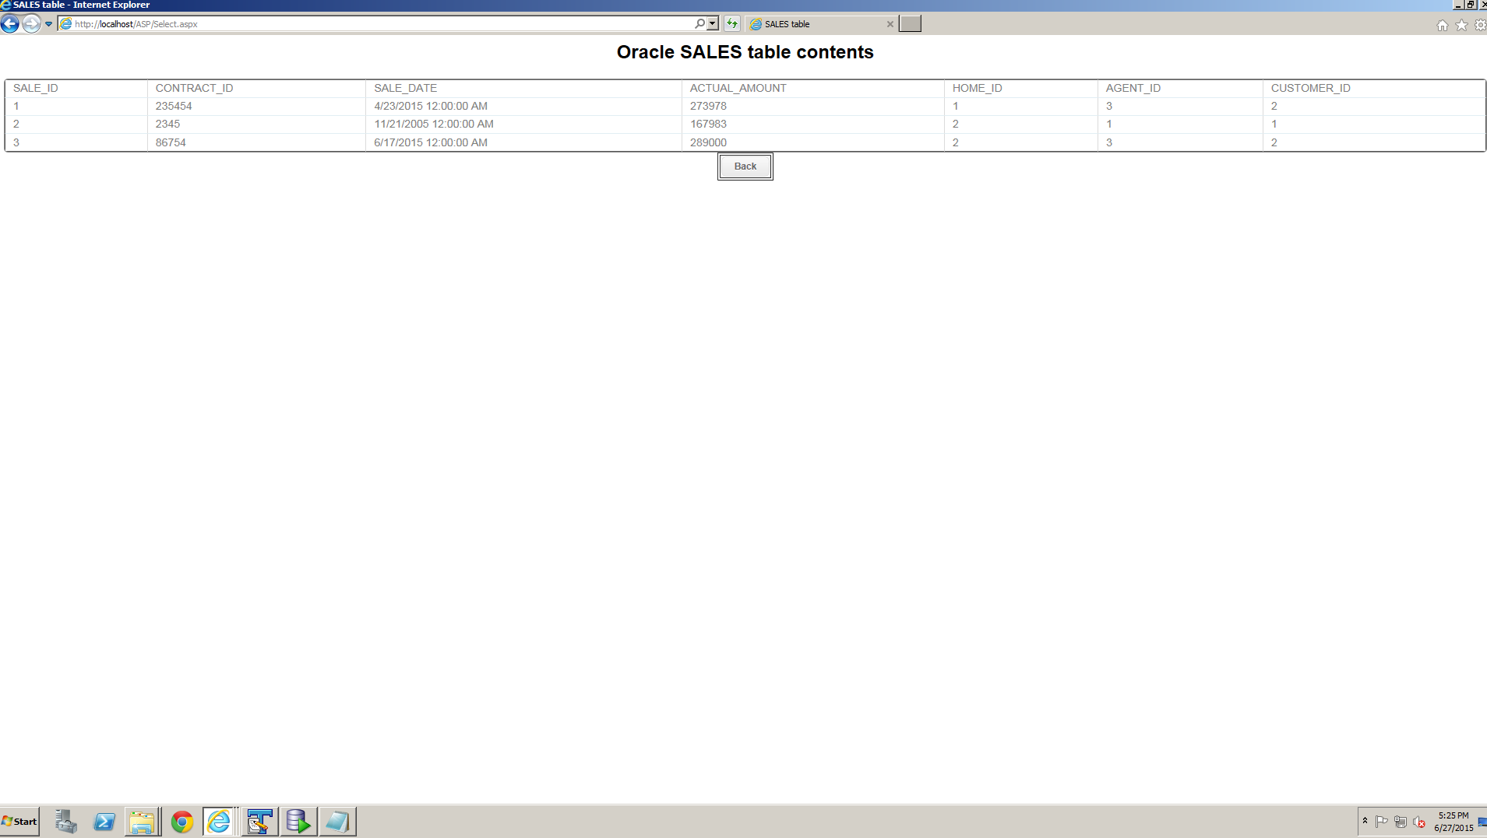

Figure 12 Select Data after insert

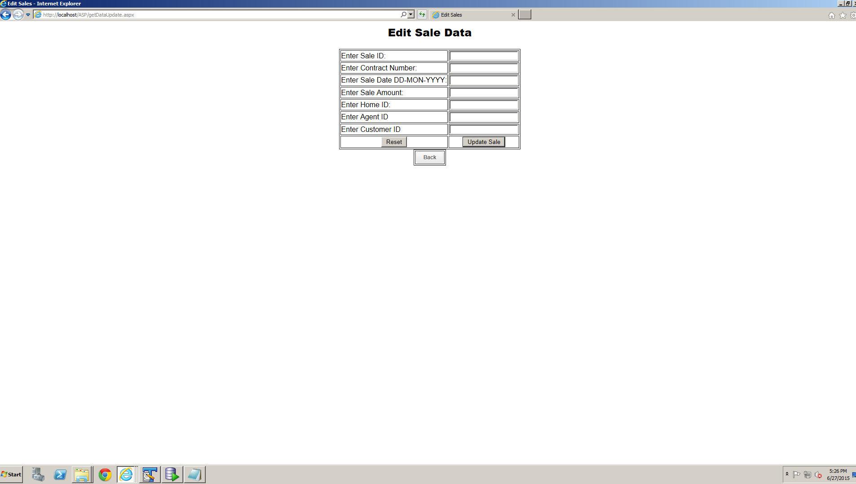

Figure 13 Edit Data Page

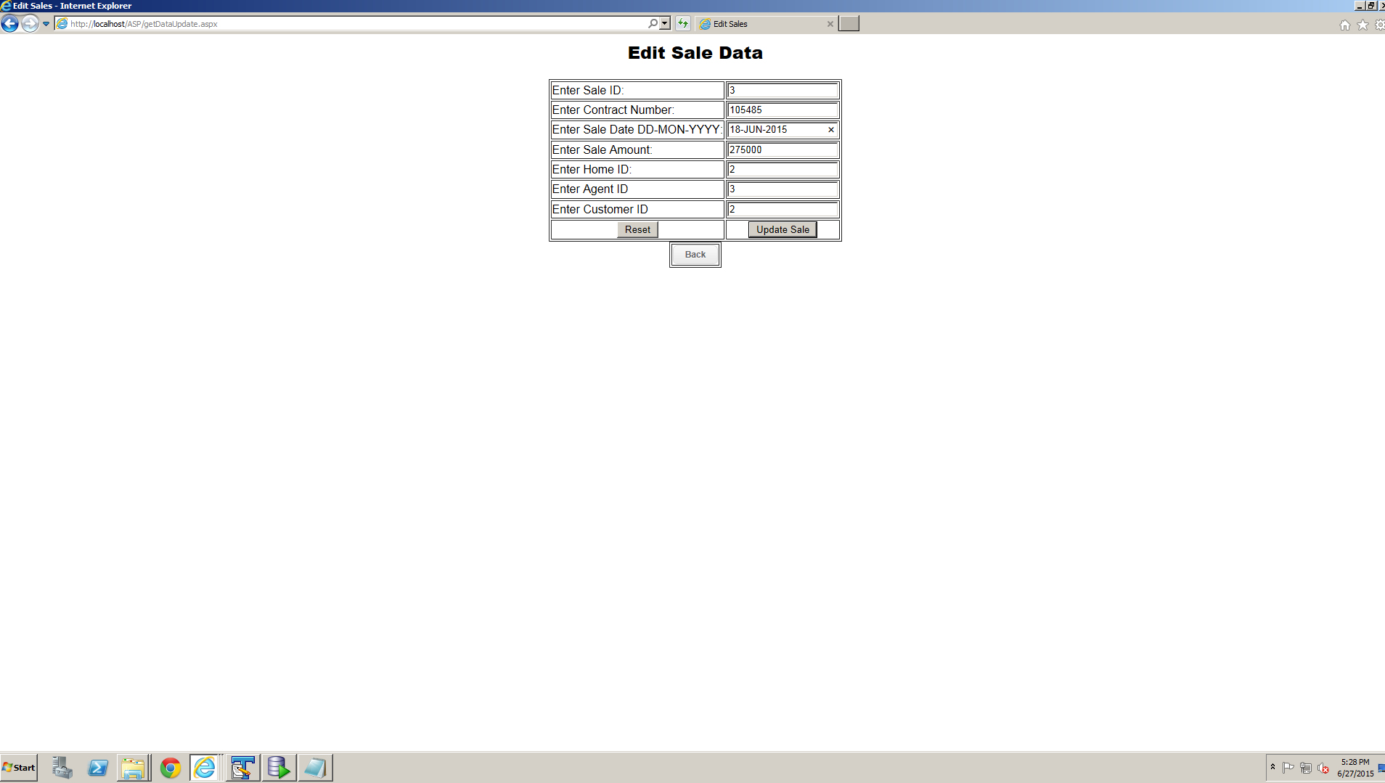

Figure 14 Edit Data form filled out

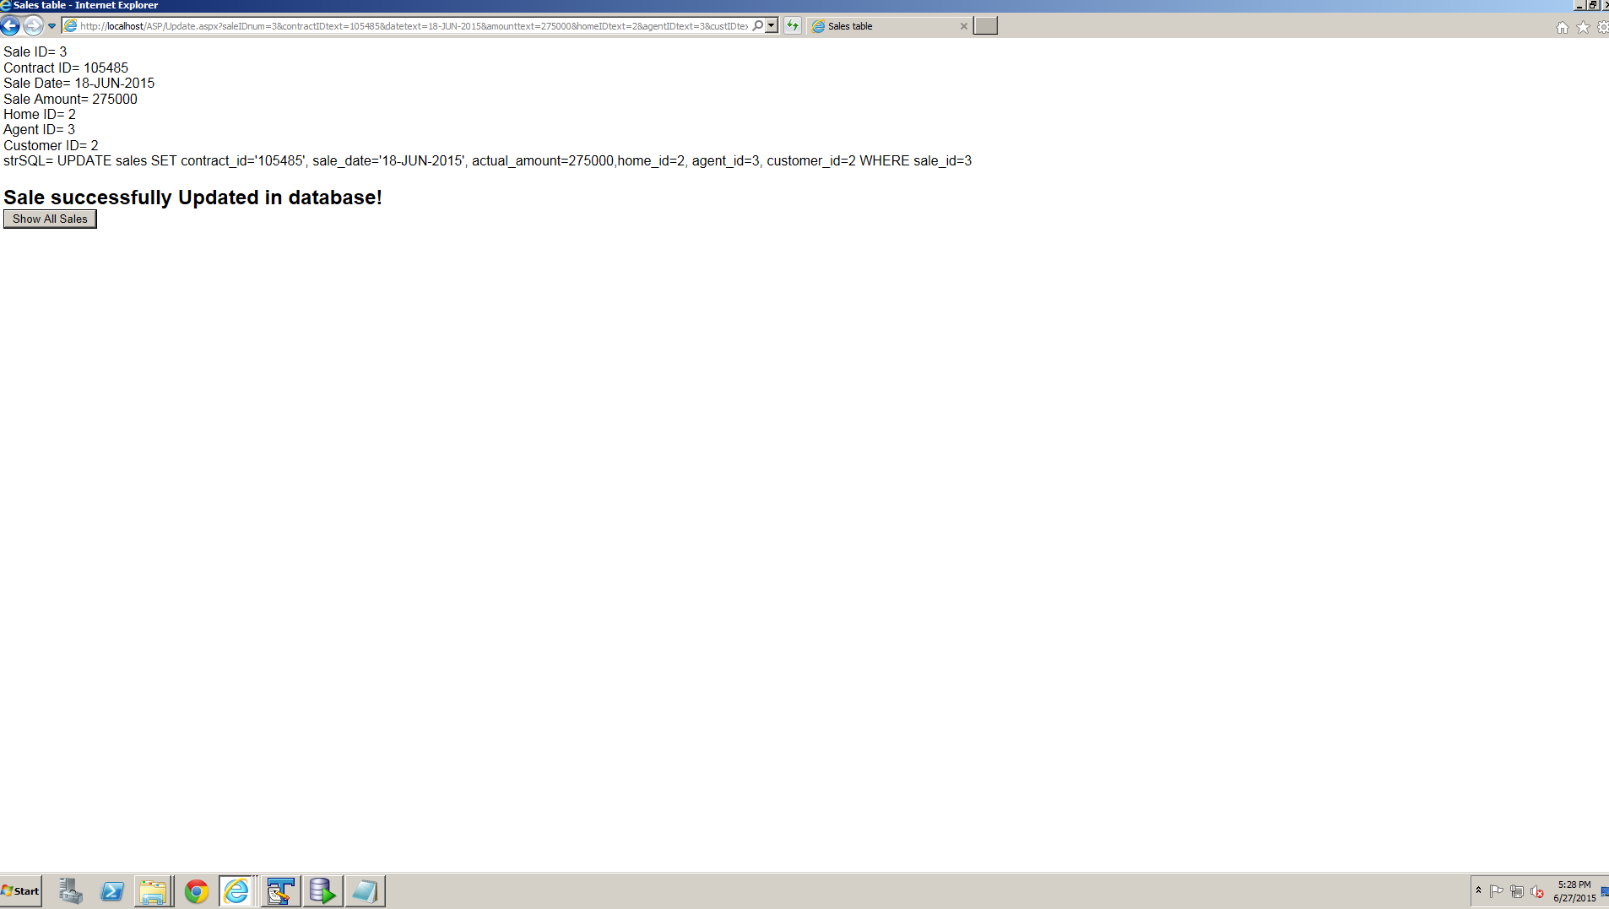

Figure 15 Edit success page

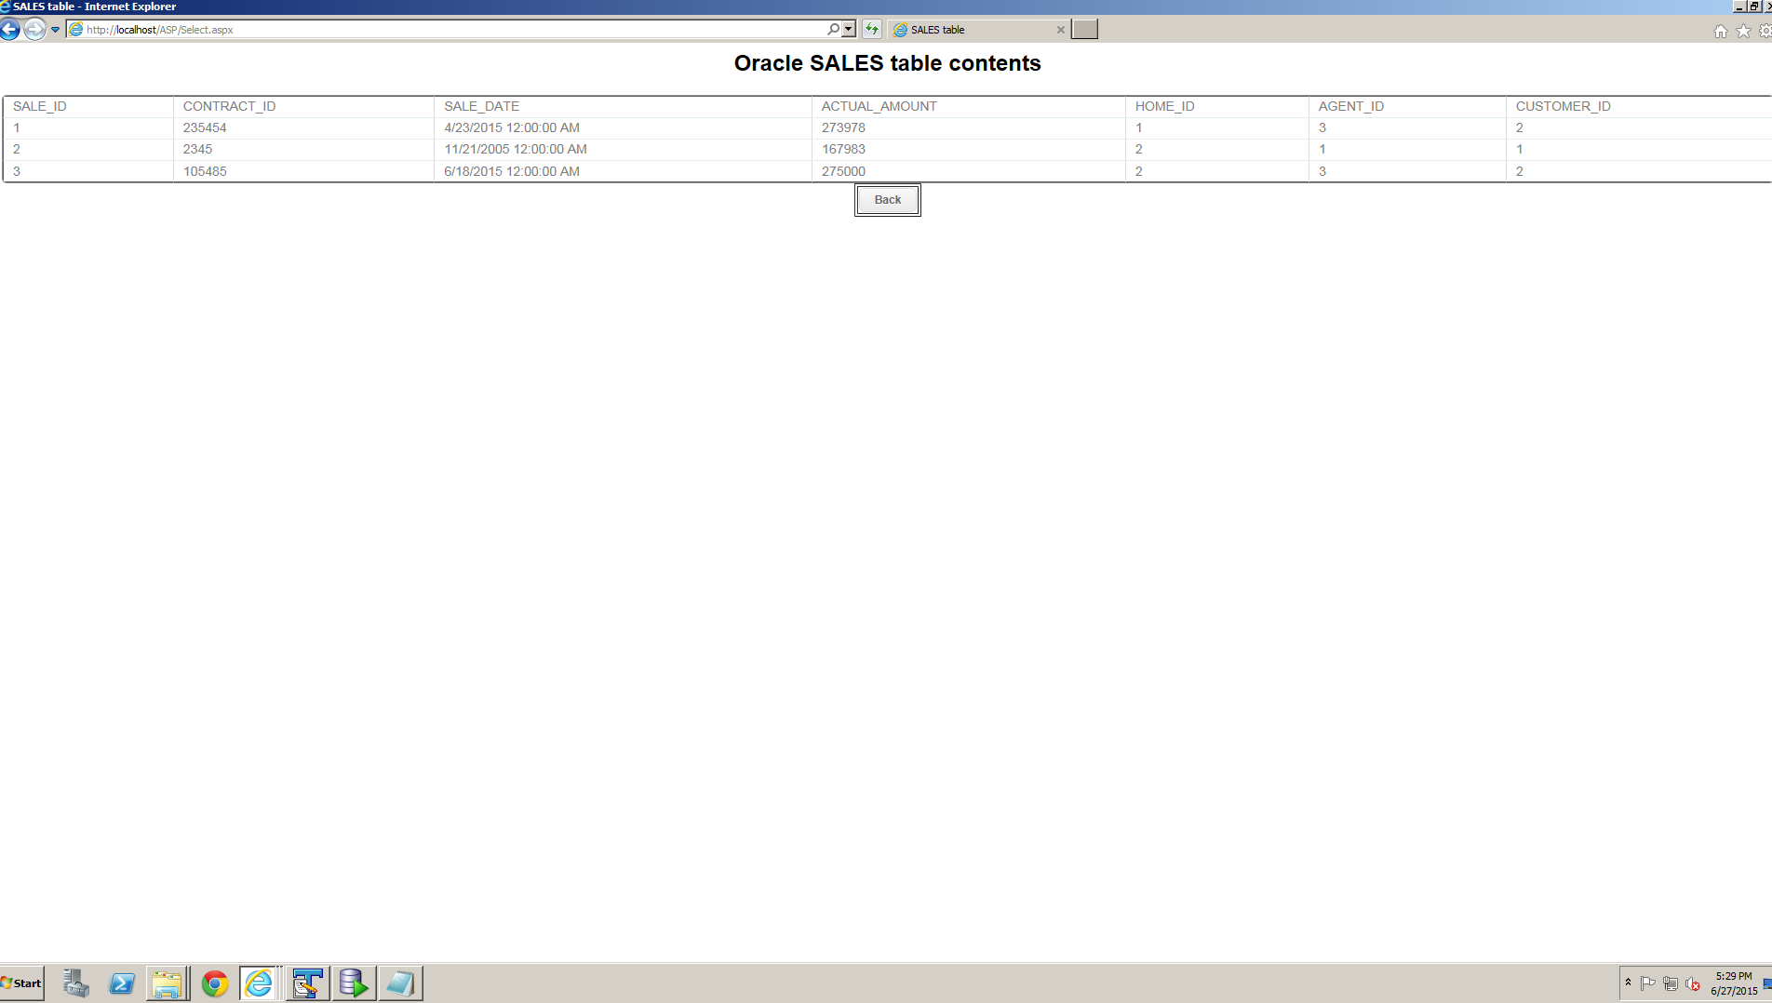

Figure 16 Select Data after edit

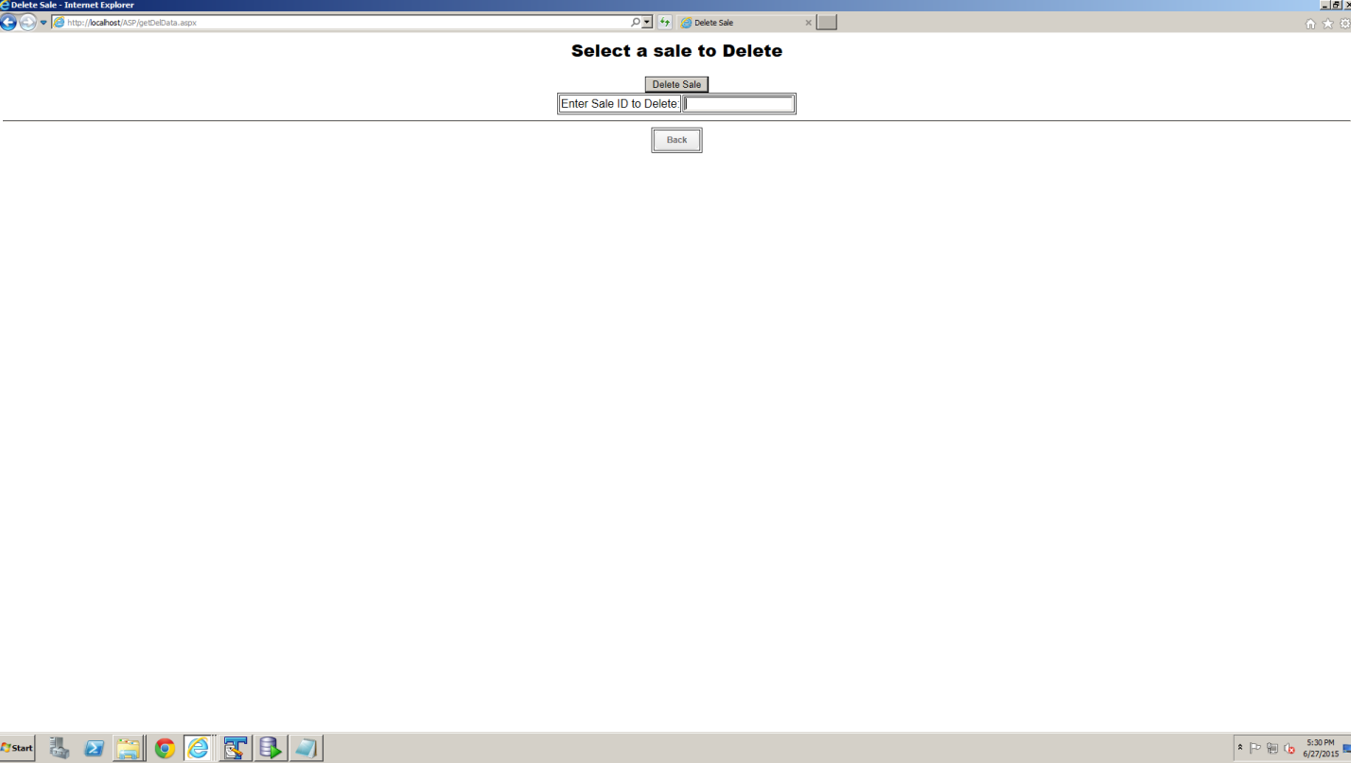

Figure 17 Delete page

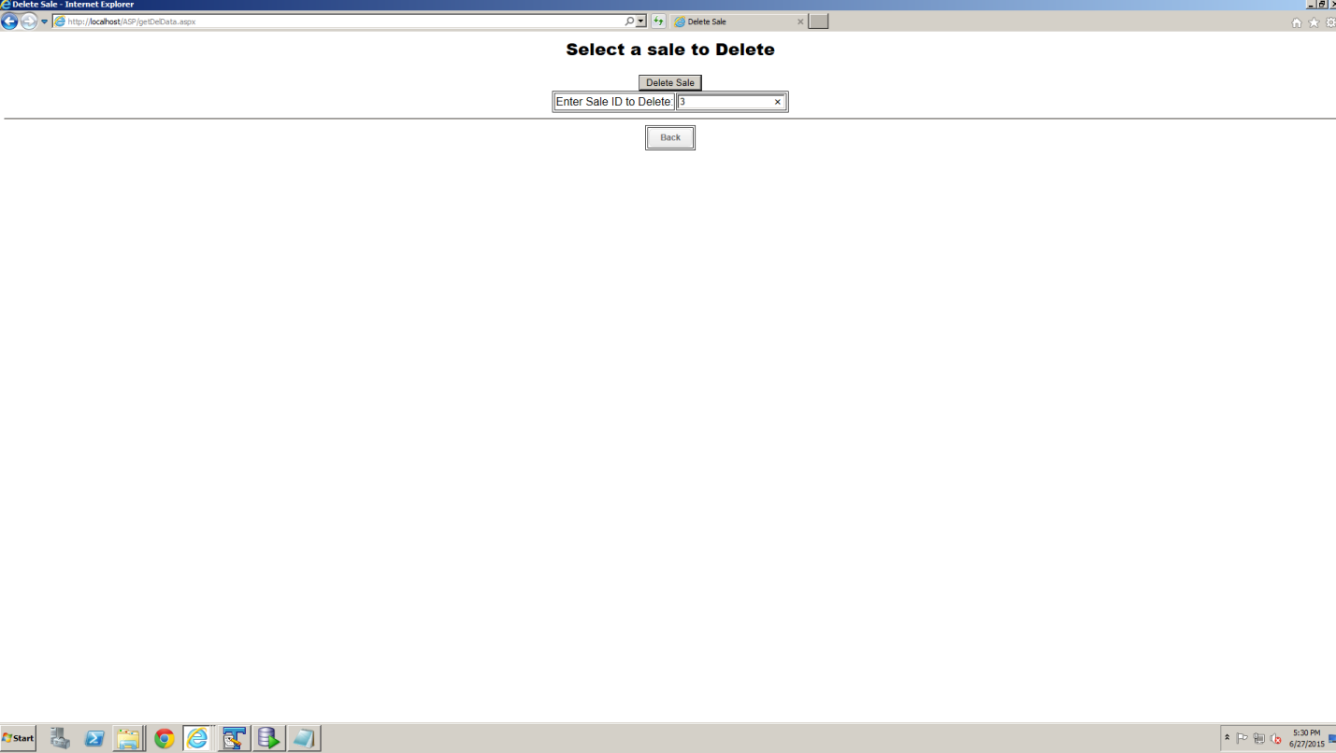

Figure 18 Delete record selected

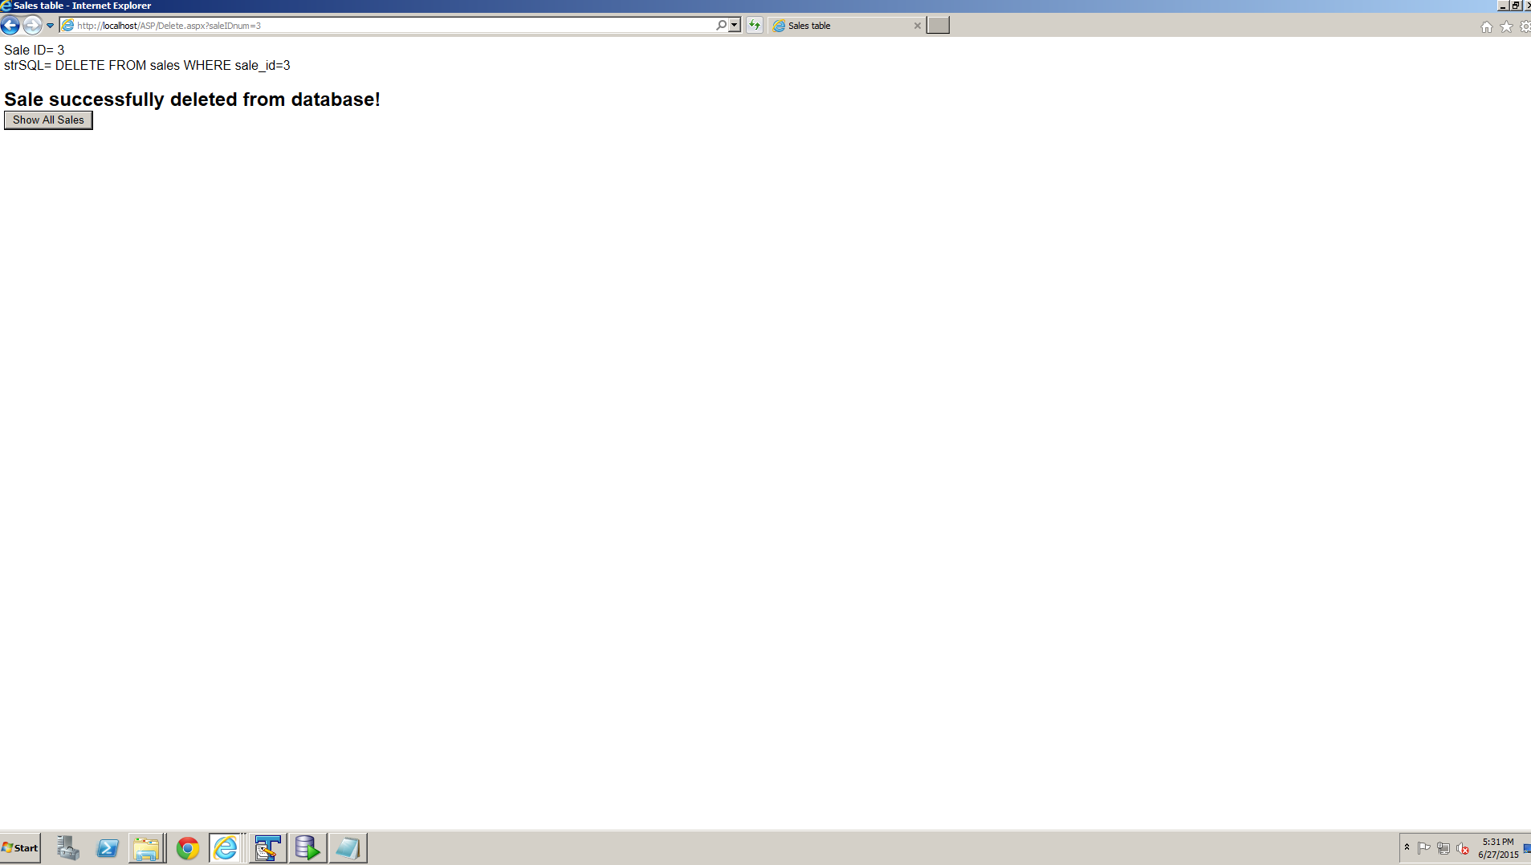

Figure 19 Delete success page

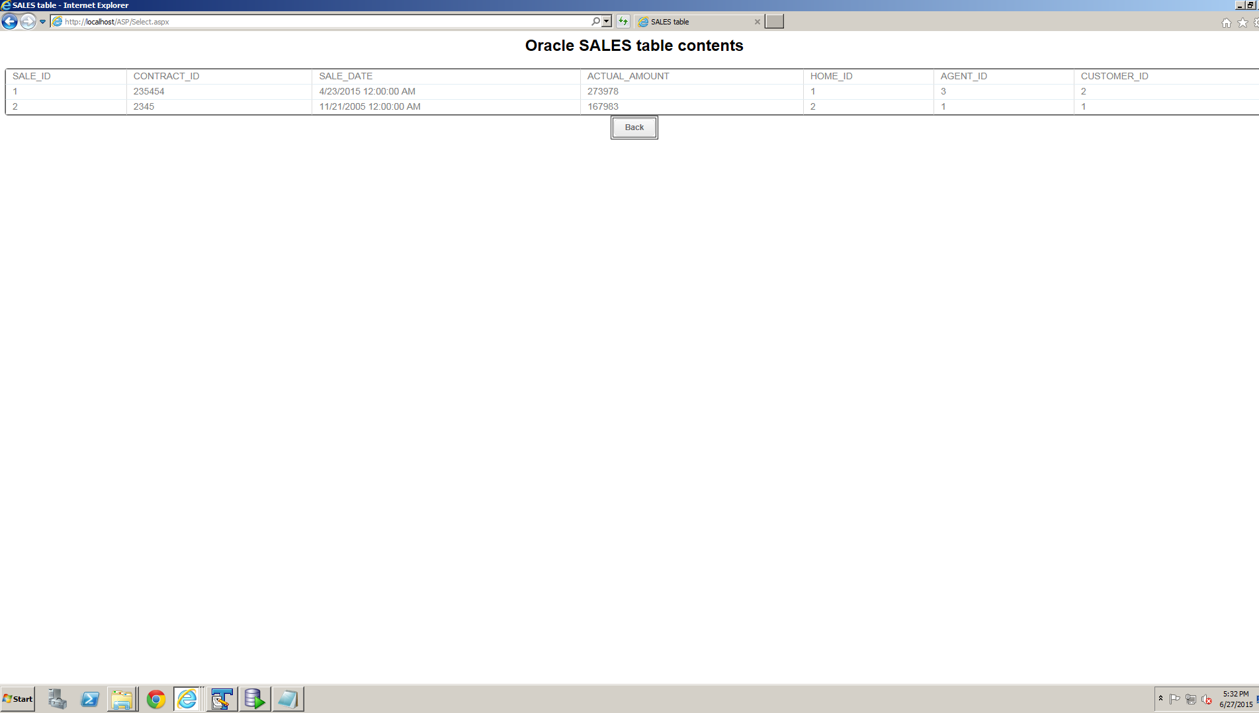

Figure 20 Select Data after delete